12/05/2025
- If the limit of the assignment is 30 pages, then that page limit shouldn’t exceed; else the French professors would disregard it. They would only read until 30 pages and woouldn’t after that.
  - They’ll provide a score based on those 30 pages only.
  - Strictly follow the structure provided by the professor

01/24/2026
- Thesis Workshop .ppt
  - By Nov/Dec we are expected to produce your thesis proposal.
    - Its going to be the main structure of the thesis paper
  - Certain points to remember when compiling your thesis
    - What would be the nice angle that you can say, well, I found out this?
    - Or I have a kind of technology where I can predict this through my study.
    - Because that is also why you can position yourself later on in this market.
  - Objective & Research Question:
    - You should think on the lines of “I would like to find out about….”. That’ll help narrow down on the exact topic.
      - Try to avoid broad topics and terminologies
    - The thesis objective should start with “The aim of this research is to……/ The objective of this research is to…..”
    - 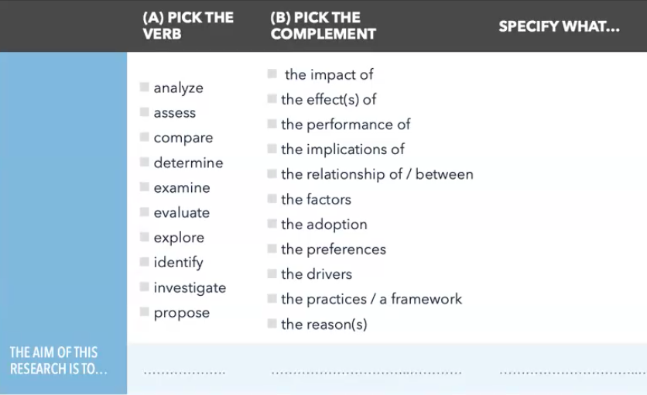
    - There should be some business context for the professors to entertain your objective
    - Revised objective for DRO - “The objective of this research is to examine how internal IT governance mechanisms—specifically Digital Resource Orchestration and software license rationalization—moderate the relationship between software waste and capital efficiency in enterprises.”
      - Issues identified:
        - The objective is politically biased. Need to make it more neutral. Already assuming that there is a relationship between software waste and capital efficiency.
        - By stating “how” in the beginning, you are already assuming that governance mechanisms moderates the relationship between software waste and capital efficiency. Replacing ‘if’ with ‘how’ has a more neutral take. If any assumptions, the literature review must support and validate those assumptions.
        - The objective of this research is to examine if internal IT governance mechanisms—specifically Digital Resource Orchestration and software license rationalization—moderates the relationship between software waste and capital efficiency in enterprises
  - Title:
    - You can make a statement and then go from General to Specific
    - You are going to try to use the same words, or similar words, that you are using in the objective.
    - There should be some business perspective/ context in the title

02/07
DBA 2 - recording link.
Feb 8th - Workshop Dr. Cardoso
https://us02web.zoom.us/rec/share/FaRNEYZiAb35nwrVgyXPgYRWwJFAdaCm1mV3NGd2bt9LPXjFR6Mnpq5V3uvSORxB.PEKo2379Sp5gwl1f?startTime=1770538628000
Passcode: 2025.Bordeaux

- Title Contd.
  - 1st Title Draft : “Moderating Capital Inefficiency: How IT Governance Mechanisms Condition the Software as a service Waste and Performance Relationship in Enterprises”
    - Moderate and condition in the same sentence implies two different meanings. Are you already establishing that there is a relationship?
    - Question - Doesn’t moderation mean conditional relationship?

  - Have multiple title options and then narrow down on one depending on how the objective is phrased. They should compliment each other and be coherent
    - General Statement + “: or ?.” + Specific (it can be focusing on anything specific like who, where, when , how, why etc.)
    - 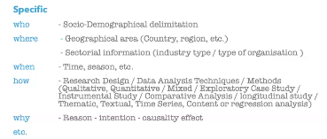
    - Having a question mark “?” in your title gets the user more interested. Try having it in your thesis title
    - Good Titles - The trick is to translate what you want to something for people who have no idea what you want get closer to what you want
  - Relevancy
    - Refer to the ‘Project de These’ .ppt for the structure
    - Why should anyone care about your thesis?
    - Max 3-5 sentences (1 paragraph)
      - General to Specific
      - Should be like a story that the reader is able to follow. Shouldn’t directly start talking about the point. Should focus on keeping the reader interested
      - There should be some business perspective/context in the paragraph
  - Abstract

